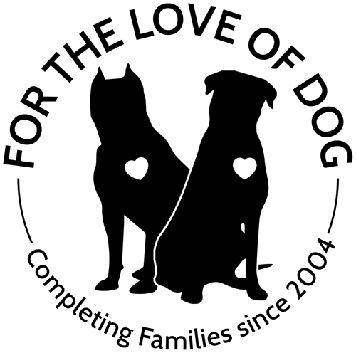 | For the Love of Dog  Rottweiler Rescue of New Hampshire  PO Box 107 Hillsboro NH 03244  www.4theloveofdog.org ~ FortheLoveofDog@tds.net

Contract for Adoption of a Dog

This agreement is made this ____ day of _______ 2020, by and between For the Love of Dog – Rottweiler Rescue of New Hampshire and ______________________ and _____________ hereinafter referred to as the "Adopters."
The adopters hereby, understands, promises and agrees that in receipt of this pet to forever release, discharge and covenant to hold harmless For the Love of Dog – Rottweiler Rescue of New Hampshire (hereinafter called “4TLOD”) and by other person, firm or organization charged and chargeable with responsibility or liability, their heirs, administrators, executors, successors, and assigns, from any and all claims, damages, and costs, expenses, loss of services, actions and causes of action belonging to the said adopters, arising out of any act or occurrence from the present time and particularity on account of the adoption of:

NAME: __________ Dog#: _____________Gender: _____________
BREED: _____________MICROCHIP#: _____________
AGE/DOB: _____________ COLOR: _____________
DISTINGUISHING CHARACTERISTICS: ______________
(Hereinafter referred to as the "dog".)

All parties agree to hold For the Love of Dog – Rottweiler Rescue of New Hampshire, its officers, directors, and volunteers harmless from any and all situations and liabilities that arise from adoption of this dog. For the Love of Dog makes no representations or testimonies as to the quality of health and/or temperament of this dog. All parties agree that this dog is transferred “As Is”.

All parties further agree to the following:
We agree that this dog will reside in our home as a “family member” and will have access to a securely fenced yard or will always be leash walked. We agree that this dog will not exclusively be left alone in a backyard or kennel and will never be chained or tied out. We agree that this dog will never be left in a crate in excess of nine [9] total hours per day. We agree to enroll in and complete an obedience course using positive reinforcement training and provide proof of completion to 4TLOD by ______________. (initials) ____________

We understand that we are committing to this dog for the entirety of its natural life. We understand that if, at any time, we are unable to keep this dog for any reason and it becomes necessary to relinquish or otherwise place this animal, 4TLOD retains FULL AND NONNEGOTIABLE RIGHTS OF FIRST REFUSAL. We agree that we are personally responsible for physically returning this dog to 4TLOD in Swanzey, NH. We understand that any donation given by the undersigned is a wholly voluntary gift and is in no sense to be regarded as a return for value received. Donations are not refundable. (initials) _________

For the Love of Dog – Rottweiler Rescue of New Hampshire
Contract for Adoption of a Dog

We agree to maintain preventative health care of this dog including, but not limited to: annual general physical examination, vaccinations or titres every three years or as recommended by the veterinarian, monthly heartworm preventative medication given continuously throughout the year and control of internal as well as external parasites. We agree that this dog will receive immediate medical treatment by a licensed veterinarian when it becomes ill or injured. All existing medical records have been transferred to new adopters with the dog. (initials) ____________

We agree to maintain the general health care of this dog in regard to wholesome food, clean, fresh water, and sufficient exercise in consideration of the size and age of the dog. Foods NOT to be fed include brands with soy products [implicated in gastric torsion] and artificial preservatives such as BHT, BHA and ethoxyquin [implicated in several types of cancers]. (initials) ____________

We agree that this dog will wear an identification name tag which includes our phone number at all times. We agree that if this dog becomes lost, every reasonable effort will be made to recover the dog, including but not limited to, notifying the Microchip company, posting on social media, visiting the local animal shelters and paying all recovery fees if the animal is seized by animal control officers. We agree that we will notify 4TLOD within 24 hours if the animal is missing. (initials) ____________

We understand and agree that 4TLOD has the right to know the whereabouts of this dog for the duration of its life and therefore agree to provide 4TLOD with our new telephone number and/or address within 14 days of any changes. (This is for Microchip purposes only.) (initials) ____________

Should 4TLOD receive notification of neglect or mistreatment, we will allow 4TLOD to inspect the animal and premises at any time. If, in the opinion of 4TLOD, the animal is being improperly cared for, we understand and agree that 4TLOD will take immediate possession of the animal at no expense to 4TLOD. we agree to immediately surrender the animal peaceably and voluntarily and will thereafter surrender all claims of any kind or nature to said pet or against 4TLOD. (initials) ____________

We understand that 4TLOD does not make any guarantee or warranty as to the health or temperament of this dog and is not responsible for any medical expenses which may be incurred in respect to this dog. We agree that this dog has been received without any warranties or guarantees, express or implied, about the dog's condition, behavior, or prior ownership. Therefore, we hereby release and discharge For the Love of Dog – Rottweiler Rescue of New Hampshire, Inc. forever from liability for any injury or damages to any person, animal or property caused in the future by said animal and from any causes of action, claims, suits or demands whatsoever that may arise as a result of such injury or damages. (initials) ____________

We agree fully to the terms of this contract. We understand that this contract is under the jurisdiction of the State of New Hampshire, in the County of Hillsborough, which shall be the place of venue for purposes of enforcement of the terms of this contract. Should 4TLOD need to seek legal action against us for any violations of this contract, we agree to assume any and all attorney costs and court fees. We acknowledge that all statements contained in this contract completed by us are true and accurate. (initials) _____________
For the Love of Dog – Rottweiler Rescue of New Hampshire
Contract for Adoption of a Dog

Additional Provisions:

(initials) _____________

Signed Adopter 1 _________________________________ Date: ________________

Signed Adopter 2 _________________________________ Date: ________________

Address: _______________________________________________

City, State, Zip: _________________________________________

Phone Number: _________________________________________

Email: ______________________________________________

Witness: ______________________________________________

Director: __________________________ Date _______________

For the Love of Dog
PO BOX 107, Hillsboro NH 03244
978-302-8171 voice mail

